Top Up Online As Parent

Document Information

|  |  |
| --- | --- |
| **Document Title** | Title of use case – Verb Noun phrasing is almost always the most appropriate! |
| **Document Owner** |  |
| **Version** |  |
| **Status** |  |
| **Date** |  |

1. Brief Description

This use case allows a parent to add funds to a student’s account balance using online wallets or bank cards whose accounts were linked to each other.

1. Actors

* Parent

1. Trigger

The parent decides to top up a student’s account balance whose accounts were linked to each other.

1. Pre-Conditions

* The parent must be logged into the system.
* The parent and student’s accounts must be linked to each other.

1. Post-Conditions

* The student's account balance is increased by the amount of the top-up.

1. Basic Flow
2. The parent logs in to the system.
3. The parent navigates to “Account Balance” section.
4. The system displays the current account balance of the student whose account were linked to the parent account.
5. The parent selects “Top up” button.
6. The parent selects the payment method.
7. The parent enters the top-up amount.
8. The parent selects “Add” button to confirms the top-up.
9. The system call the selected payment gateway.
10. The payment gateway displays the necessary payment information.
11. The parent enters the required payment information.
12. The parent confirms the payment.
13. The payment gateway process the payment.
14. The payment gateway updates the processing result to the SLOS system.
15. The system updates account balance to reflect the top-up amount.
16. The system returns the parent to “Account Balance” page.
17. Alternate Flows
18. Exception Flows

* 7a. If the parent enters invalid top-up amount (>5.000.000), the system displays an error message and the parent must enter a lower amount at step 4.
* 8a. If the system does not call the payment gateway successfully, the system displays an error message and returns to step 4.
* 9a. If the parent does not want to continue the payment process, they can select “Cancel” button or any similar button depends on the payment method to cancel the payment process. The system returns the parent to step 4.
* 11a. If the required payment information is not correct, the payment processing displays an error message and the parent must enter the correct information or cancel the payment process.
* 14a. If the payment processing is not successful, the systems displays an error message and returns to step 4.

1. Business Rules

* The maximum for each time to top up is 5.000.000.
* Only online wallets and bank cards available for selected are accepted as payment methods for online top-up.
* The online top-up amount should be positive.

1. Non-Functional Requirements

* The system should be available 24/7 with 99% uptime.
* The system should process the payment processing and balance calculating quickly (5s).
* The system should provide clear and concise messaging to the parent throughout the top-up process.

1. Supplemental Requirements
2. Visual Model

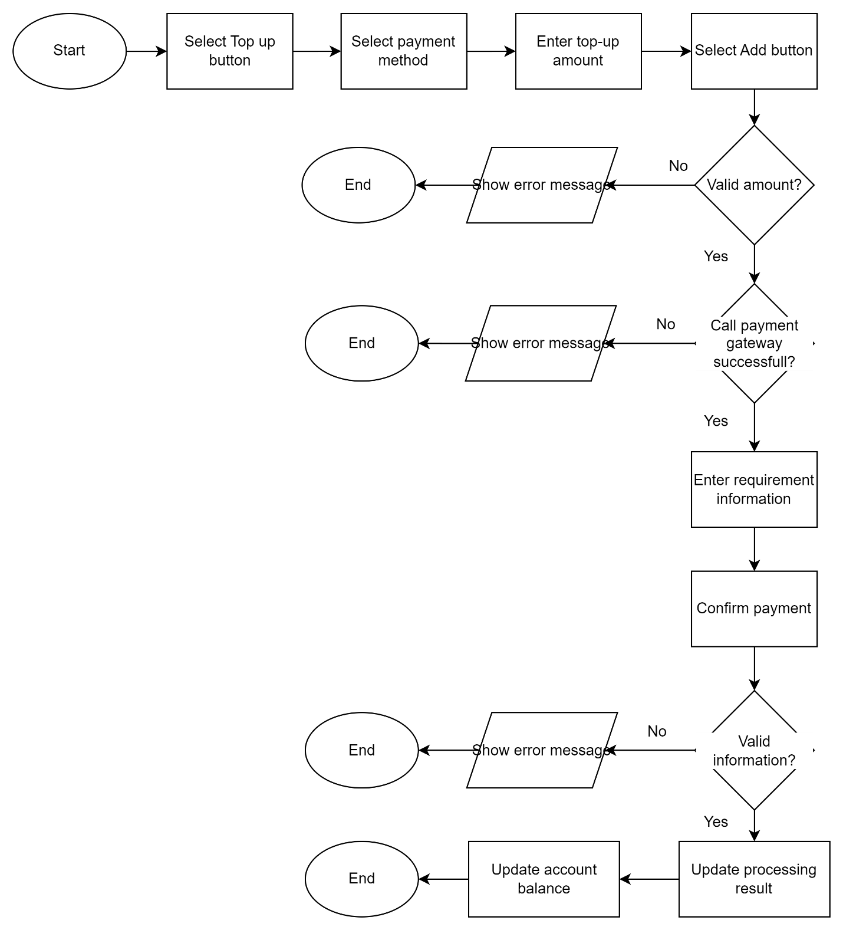

Revision History

|  |  |  |  |  |
| --- | --- | --- | --- | --- |
| V. | Date | Author | Description | Status |
|  |  |  |  |  |
|  |  |  |  |  |